**Assignment 1.3 – Setup, Debugging, and Diagnostics**

Brooks

Bellevue University

WEB 340-339A Node.js

January 8th, 2023

Professor Krasso

**Part 1 – Installation:**

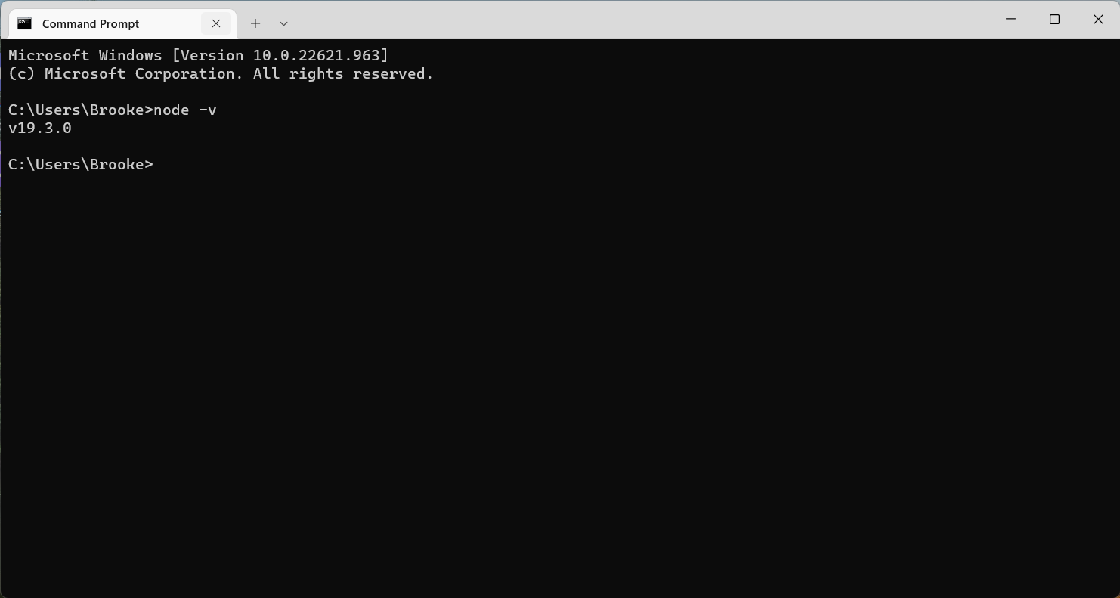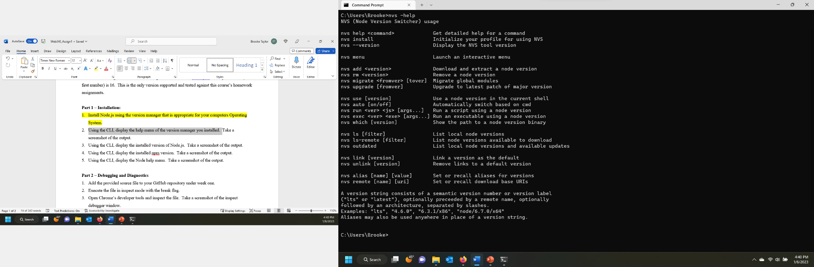

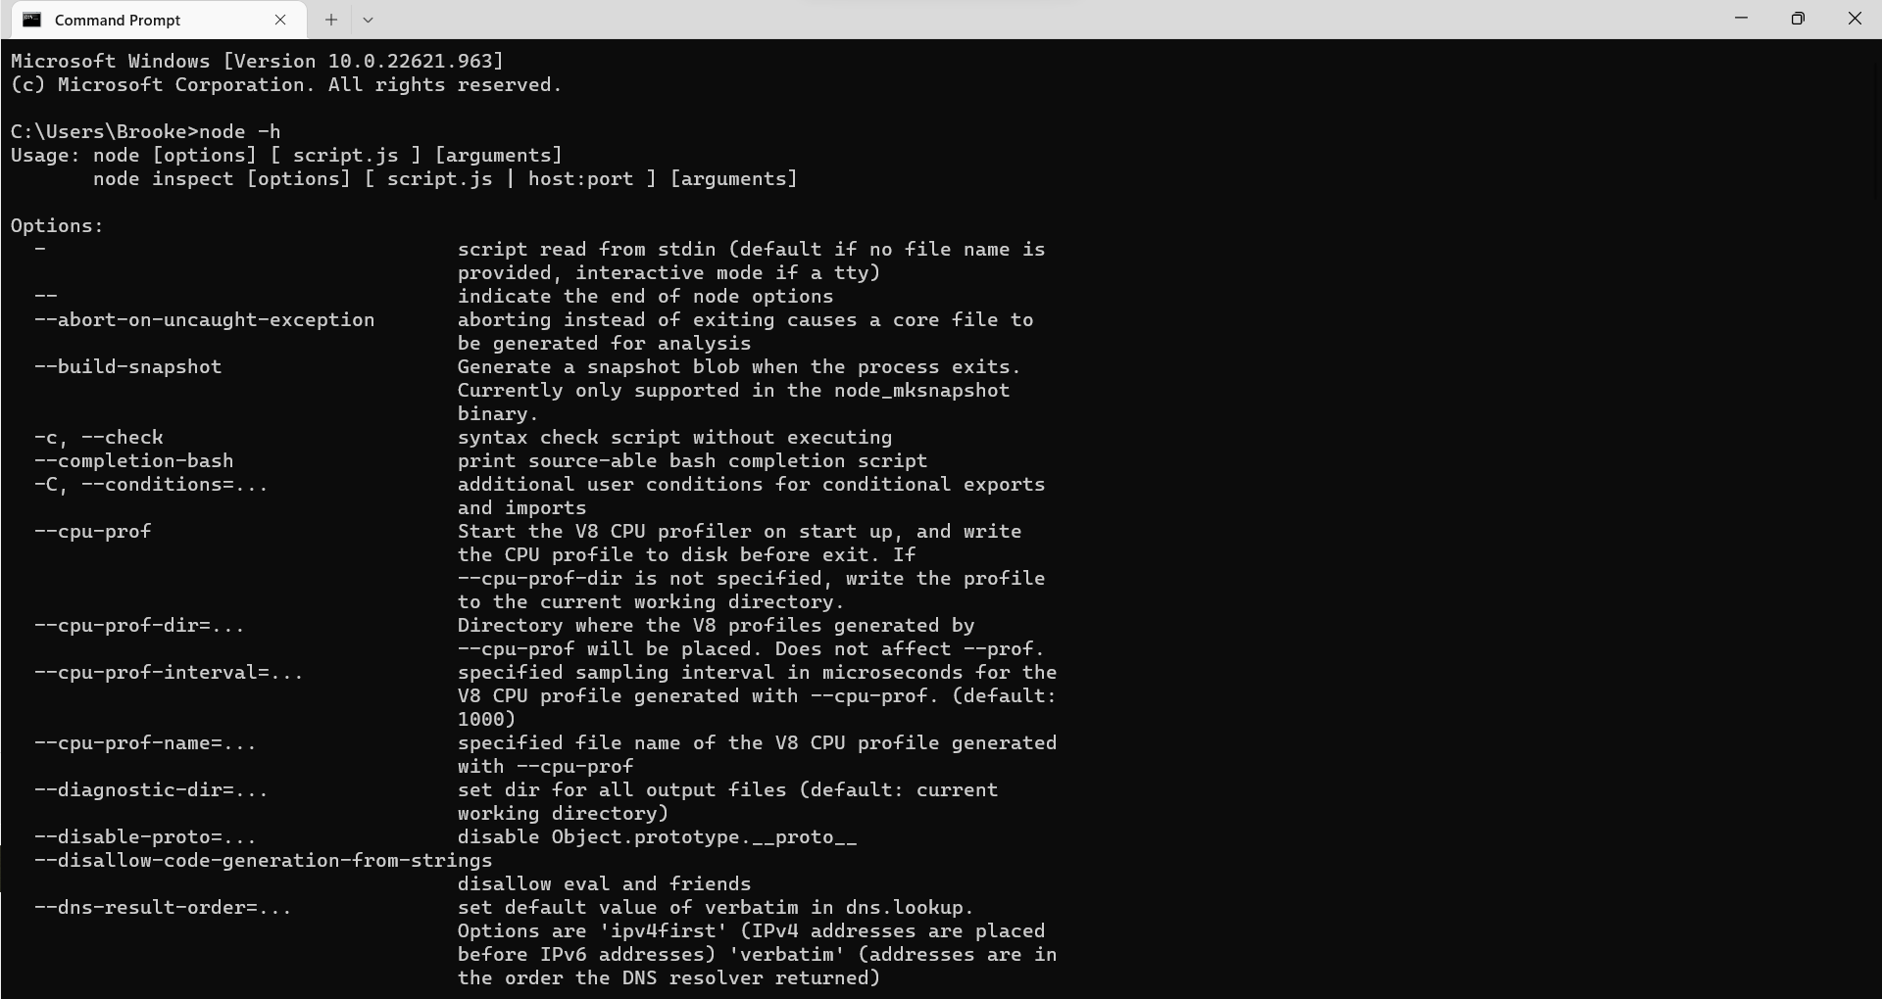

**Part 2 – Debugging and Diagnostics**

